OASIS INFOBYTE

DATA ANALYTICS INTERNSHIP.

Customer Segmentation Analysis Using K-Means Clustering.

Project Report

Submitted By
Name: Prayan v
Email: 24bsr18035@jainuniversity.ac.in
College/University: jain university school of sciences

Submitted To
Oasis Infobyte
Data Analytics Internship Program

Project Duration
June 2026

Tools & Technologies Used
• Python
• Pandas
• NumPy
• Matplotlib
• Scikit-Learn
• Google Colab

Declaration
I hereby declare that this project report titled "Customer Segmentation Analysis Using K-Means Clustering" has been completed by me as part of the Data Analytics Internship Program offered by Oasis Infobyte. The work presented in this report is original and has been carried out using the provided dataset and analytical techniques

1. Introduction
Customer segmentation is the process of dividing customers into distinct groups based on their characteristics and purchasing behavior. Businesses use customer segmentation to understand customer needs, improve marketing strategies, and increase profitability.
The objective of this project is to analyze customer data and group customers into meaningful segments using the K-Means Clustering algorithm.

2. Objectives
- Perform data cleaning and preprocessing.
- Analyze customer income and spending behavior.
- Create a Total Spending feature.
- Apply K-Means Clustering to identify customer segments.
- Visualize customer groups.
- Generate actionable business recommendations.

3. Dataset Description
The dataset contains 2205 customer records and includes the following attributes:
- Income
- Kidhome
- Teenhome
- Recency
- MntWines
- MntFruits
- MntMeatProducts
- MntFishProducts
- MntSweetProducts
- MntGoldProds
A new feature named Total_Spending was created by summing all product spending categories.
Formula:
Total Spending = MntWines + MntFruits + MntMeatProducts + MntFishProducts + MntSweetProducts + MntGoldProds

4. Data Cleaning and Preprocessing
The following preprocessing steps were performed:
- Loaded the dataset using Pandas.
- Checked for missing values.
- Checked data types.
- Created Total_Spending feature.
- Selected Income and Total_Spending for clustering.
Results:
- Total Records: 2205
- Missing Values: 0
- Duplicate Values: 0
The dataset was clean and ready for analysis.

5. Exploratory Data Analysis

Income Distribution
Income distribution was analyzed to understand customer purchasing power. The dataset contains customers with varying income levels, indicating diverse customer groups.

Spending Distribution
Total customer spending was analyzed to understand purchasing behavior. Spending varied significantly across customers, making segmentation appropriate.

Income vs Spending Analysis
A scatter plot of Income versus Total Spending showed clear separation among customer groups, indicating that clustering techniques can effectively identify segments.

6. K-Means Clustering

Elbow Method
The Elbow Method was used to determine the optimal number of clusters.
The graph showed a clear bend at K = 4, indicating that four customer segments would provide the best balance between simplicity and accuracy.
Therefore:
Number of Clusters = 4

7. Customer Segments

Cluster 0 – VIP Customers
- Average Income: 80,048
- Average Spending: 1,405.87
- Customers: 463
Characteristics:
- Highest income group.
- Highest spending behavior.
- Most valuable customers.

Cluster 1 – Budget Customers
- Average Income: 23,280
- Average Spending: 73.47
- Customers: 455
Characteristics:
- Lowest income group.
- Lowest spending behavior.
- Highly price-sensitive customers.

Cluster 2 – Loyal Customers
- Average Income: 61,611
- Average Spending: 816.75
- Customers: 622
Characteristics:
- Stable income.
- Consistent purchasing behavior.
- Largest customer segment.

Cluster 3 – Regular Customers
- Average Income: 41,880
- Average Spending: 219.06
- Customers: 665
Characteristics:
- Moderate income.
- Average spending patterns.
- Potential for growth through targeted marketing.

8. Visualizations
The following visualizations were created:
- Income Distribution Histogram
- Spending Distribution Histogram
- Income vs Spending Scatter Plot
- Elbow Method Graph
- Customer Segmentation Scatter Plot
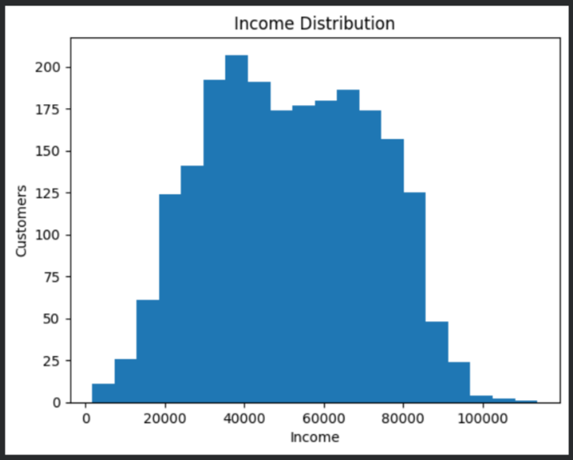
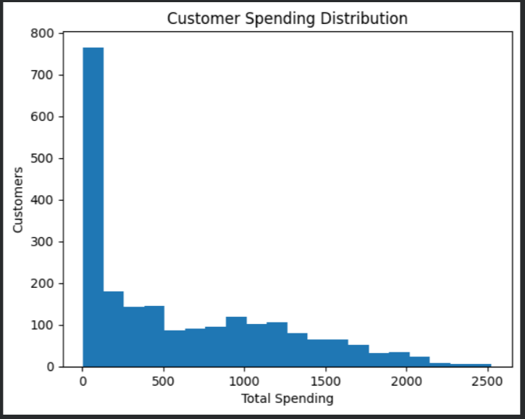
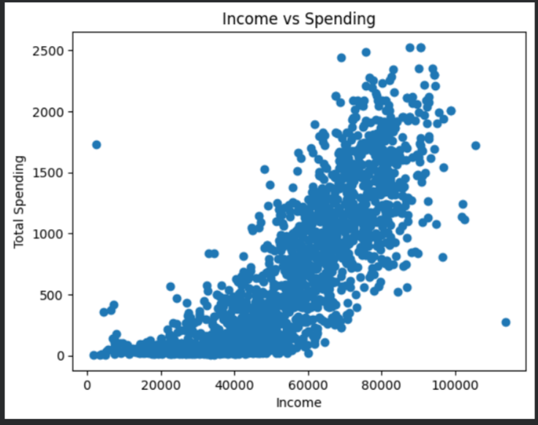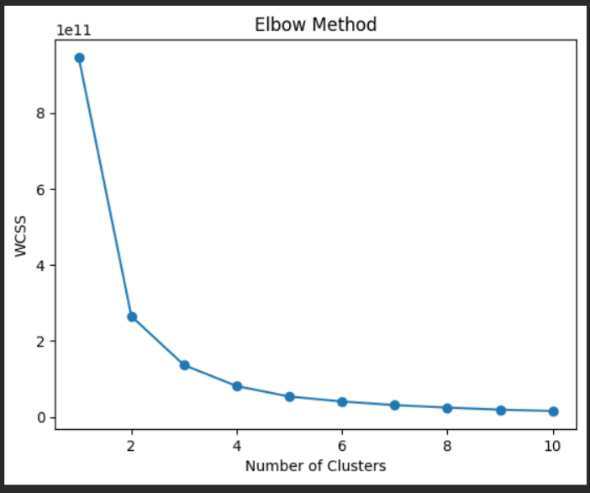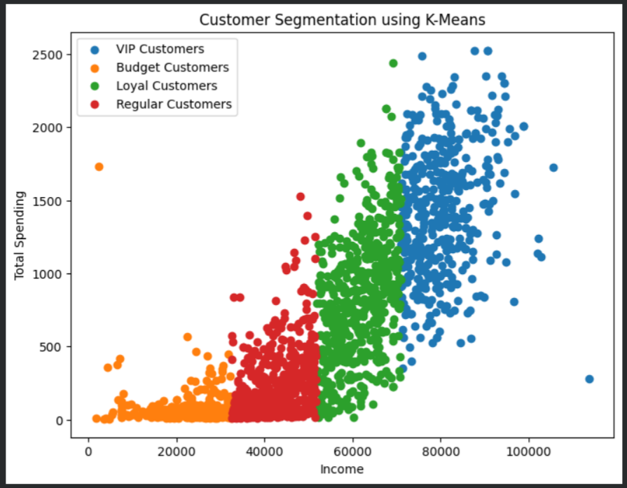

9. Key Insights
- Four distinct customer segments were successfully identified using K-Means Clustering.
- VIP Customers have the highest income and spending levels and contribute significantly to business revenue.
- Loyal Customers represent the largest segment and generate consistent revenue.
- Regular Customers provide opportunities for upselling and customer growth.
- Budget Customers are highly price-sensitive and respond well to discounts and promotions.
- Customer spending behavior is strongly influenced by income levels.

10. Recommendations

For VIP Customers
- Offer premium membership programs.
- Provide exclusive rewards and personalized services.

For Loyal Customers
- Implement loyalty programs.
- Offer targeted recommendations and incentives.

For Regular Customers
- Use upselling and cross-selling strategies.
- Introduce personalized marketing campaigns.

For Budget Customers
- Offer discounts and value-based packages.
- Promote affordable products and special offers.

General Recommendations
- Use customer segmentation for targeted marketing.
- Monitor customer behavior regularly.
- Develop strategies to move customers into higher-value segments.

11. Conclusion
This project successfully applied K-Means Clustering to segment customers based on income and spending behavior. Four distinct customer groups were identified: VIP Customers, Loyal Customers, Regular Customers, and Budget Customers.
The findings demonstrate how machine learning and customer analytics can help businesses improve customer targeting, increase revenue, and optimize marketing strategies.
Customer segmentation provides valuable insights that support data-driven decision-making and long-term business growth.

References
- Python Documentation
- Pandas Documentation
- Scikit-Learn Documentation
- Oasis Infobyte Data Analytics Internship Resources

